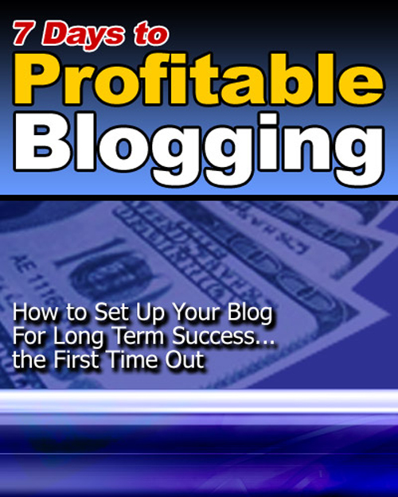
PLR & Master Resale Rights License Agreement

Dear valued customer,

Congratulations and thank you for your investment in the PLR & Master rights license to “7 Days to Profitable Blogging”! This is a quality product with great information and I’m sure you’ll benefit from it.

Before you start, please read the following:

Important Information

Please read these terms:

1. You must keep this master rights PDF license to verify yourself as an official holder of the license. You must also be able to produce it on demand should the need arises.

2. Please note that I cannot legally guarantee that you’ll make any money with the basic resale rights or from the product itself. Your income will depend solely upon your own efforts.

3. You are responsible for providing your own hosting, download
locations and customer service support to your own customers. I do not provide instructions for setting your site up.

4. You may sell the PLR & Master resale rights opportunity to the product in itself as what I’ve done. You may not, under any circumstances, give away or add this product on a free membership site.

5. You must provide this Document to anyone you sell the resale rights to.

6. You MAY NOT market the product in any immoral or unethical manner, including UCE - unsolicited commercial email, also known as SPAM.

7. Any violation of this agreement will be subject to a revoking of your basic resale rights license in which case all monies paid will be forfeited.
This constitutes the entire "7 Days to Profitable Blogging” PLR Master Resale Rights License Agreement. Any disputes or terms not discussed in this agreement are at the sole discretion of Louis Burleson.

Thanks again and I wish you the best in all your information marketing
ventures!

